Instructions of suction type Hand-print printer

- Rack screen: put in the screen and tighten the screws.
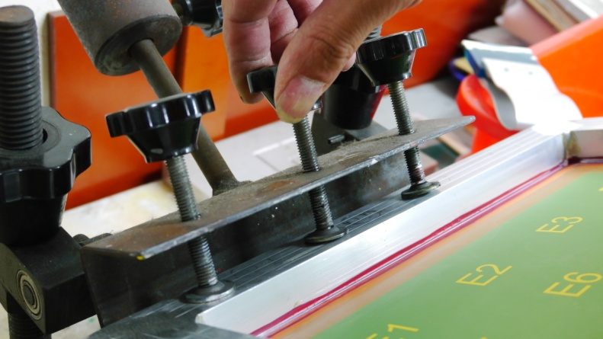
- Adjust the height of the screen,and pay attention the level.
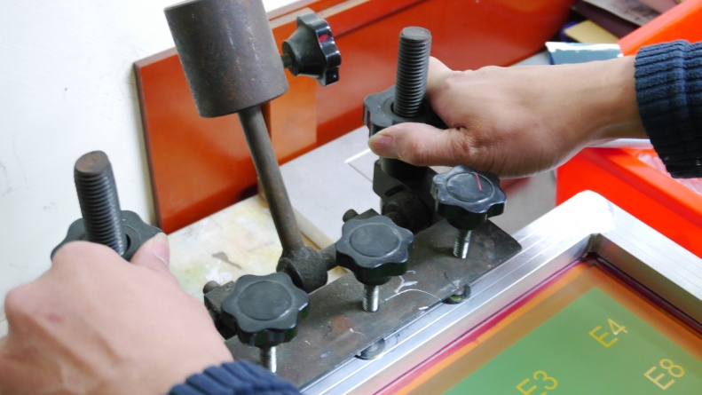
- Adjust the print position:loosen the side screws to adjust the position of the printing platform front,back,left,and right.
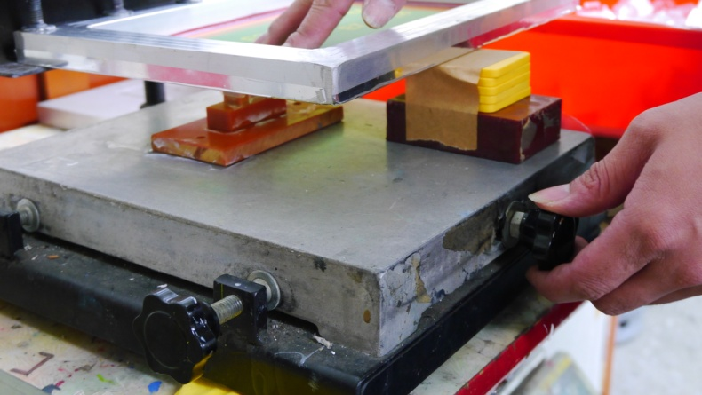
- Pour ink on the screen to start printing.

